Come Read with Us!

Are you curious about Dante’s famous Inferno, or his epic journey from the depths of Hell into the starry Heavens? Want to read or reread a classic of Christian and Western literature, while being guided through each canto of the poem by an experienced Dante teacher?

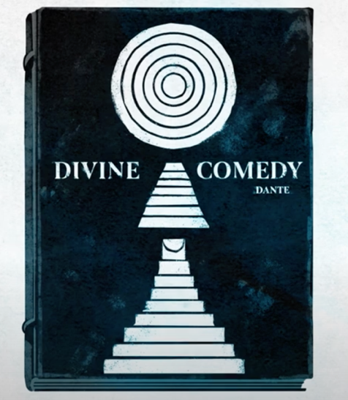

Join us for 100 Days of Dante!

Where: {OUR LOCAL LIBRARY}

When: {THURSDAY NIGHTS 7-8}

What: {Come to a weekly discussion of Dante where we can sit, talk and discover Dante together!}

How: {Sign up to get the cantos delivered to your inbox at 100daysofdante.com, and then join us for a weekly recap discussion}

Brought to you by
Baylor University Honors College
with support from
Torrey Honors College at Biola University
Templeton Honors College at Eastern University
University of Dallas
Gonzaga University and the Gonzaga-in-Florence Program
Whitworth University
The M.J. Murdock Charitable Trust

